

Course Project

Machine Learning (CS-415)
Department of Computer Science-CCSIT

AI Essay Detector
A project submitted as a requirement for the course “Machine Learning (CS-415)”

Basel Ahmed Sardah
222453505

Supervisor
Prof. Alaa Sagheer

Introduction/Background
With the rapid advancement of generative AI models, particularly Large Language Models (LLMs) such as ChatGPT, Gemini, and DeepSeek, the ability to produce human-like, grammatically correct text has improved significantly. This has led to a proliferation of AI-generated content. While utilizing LLMs to generate essays and reports can be beneficial for summarizing information and assisting with writing tasks, it also presents risks. The authoritative and confident tone of these models often leads users to trust the content without proper verification [1,2]. Consequently, distinguishing between human-written and AI-generated text has become a significant challenge.

This issue can be critical, particularly in high-stakes fields such as journalism. Studies indicate that sectors like healthcare and elections are increasingly exposed to AI-generated content [3,4,5]. The potential for spreading misinformation, manipulating public opinion, and generating propaganda remains a deeply concerning threat.

Literature Review

Simple ML Models:
Since the rise of Deep Learning models, they have become the preferred choice for most Natural Language Processing (NLP) tasks, including AI-generated text detection. However, Simple machine learning models still maintain their relevance in this field. For instance, an Extreme Gradient Boosting (XGBoost) model was utilized in [6] to detect AI-generated text, achieving an F1-score of 99% using NELA features extracted from the text. In the same study, researchers compared these results with other classical models, such as Random Forest and SVM, finding that XGBoost outperformed both; nevertheless, all three models achieved high accuracy in predicting AI-generated text. Conversely, SVC struggled with model attribution identifying the specific generator , reaching an F1-score of only 54% at best. Random Forest performed better with a peak F1-score of 80%, while XGBoost remained superior with a top F1-score of 84% for model detection.
This demonstrates that simple models can still achieve high accuracy when paired with effective Feature extraction techniques. Such models can be used to build efficient and accurate detection systems, provided that more robust features are employed.

The strength of these models lies in their Interpretability, lower computational requirements, and ease of implementation. However, they may struggle to capture complex linguistic patterns compared to deep learning models. Furthermore, the study did not address Paraphrasing attacks, which can significantly reduce a model's accuracy.

2.Zero-shot Detectors:
Another approach to detecting AI-generated text involves the use of zero-shot detectors, such as GPT-like models. These models analyze text and provide a likelihood score indicating whether the content is AI-generated or human-written without requiring task-specific training data. Studies have shown that these models can achieve state-of-the-art performance in AI-generated text detection [7]. However, zero-shot detectors often require significant computational resources and may lack the interpretability of simpler machine learning models. Additionally, their performance can vary depending on the specific text being analyzed and the model's underlying training data. For instance, in [8], Fast-DetectGPT recorded a True Positive Rate (TPR) of only 0.3% at a 1% False Positive Rate (FPR) when subjected to an AdvPara (RoBERTa-Large) paraphrasing attack.

3. Watermarking Techniques:
Watermarking techniques involve embedding hidden patterns or signals within AI-generated text to make it identifiable [7]. These techniques can be effective in distinguishing AI-generated content from human-written text; however, watermarking requires direct cooperation from AI model developers and may not be universally applicable to all types of generated text. Additionally, watermarks are susceptible to being removed or altered by adversarial actors, which significantly reduces their overall effectiveness.

Problem Statement and Objectives
The primary problem addressed in this project is the challenge of detecting AI-generated text, particularly within fake news articles. This task is crucial due to the significant potential for misinformation, public opinion manipulation, and the spread of propaganda.

Our objective is to develop a pipeline that utilizes various linguistic and statistical features to train and evaluate multiple machine learning models for AI-generated text detection. By comparing the performance of these models, we aim to identify the most effective approach for accurately distinguishing between human-written and AI-generated text, as well as performing Model Attribution to identify the specific model that generated the content.

Methodology and Proposed Solution
In this project, we aim to build a pipeline that utilizes a comprehensive set of features, including Perplexity calculation using GPT-2, Burstiness, Type-Token Ratio (TTR), Stylometry, Uniform Information Density, LIWC, Semantic Consistency, Syntax Tree Depth, and others .Then compare the performance of various traditional machine learning models—such as XGBoost, Random Forest, SVM, Naive Bayes, Linear Classifier, KNN, and AdaBoost—alongside a Neural Network built with PyTorch and optimized with Focal Loss, to identify the most effective model for this task.

This approach was chosen because classical machine learning models have demonstrated promising results in previous studies. By combining them with robust feature extraction techniques, we can develop an efficient and accurate AI-generated text detection system. The models are evaluated using standard metrics, including Accuracy, Precision, Recall, and F1-Score, to determine their effectiveness in distinguishing human-written from AI-generated text.
Implementation steps:
- Data Collection: Gather a dataset comprising essays and articles from both human and AI sources.
- Data Preprocessing: Clean and process the text data to prepare it for feature extraction.
- Feature Extraction: Extract relevant linguistic and statistical features from the text data:
  - Perplexity: Calculated using GPT-2.
  - Burstiness: Determined via the nltk library.
  - Type-Token Ratio (TTR)
  - Stylometry Analysis: Measured using the Complex Words Ratio.
  - Uniform Information Density: Derived using GPT-2.
  - LIWC Analysis: Conducted via the Empath library.
  - Syntax Tree Depth: Analyzed using Spacy.
  - Semantic Consistency: Evaluated using all-MiniLM-L6-v2.
- Model Training: Train various machine learning and deep learning models using the extracted features.
- Model Evaluation: Assess each model's performance using the established evaluation metrics.
- Model Comparison: Analyze the results across all models to identify the most effective approach for AI-generated text detection and model attribution.

Experiments and Dataset
For this project, we utilize the gsingh1-py dataset available on Hugging Face [9]. This dataset contains a collection of human-written and AI-generated essays and articles, making it suitable for training and evaluating our models. Introduced in [8], it comprises New York Times news articles published since the year 2000, along with the prompts used to generate AI text via Gemma-2-9b, Mistral-7B, Qwen-2-72B, LLaMA-8B, Yi-Large, and GPT-4-o. The dataset contains over 58,000 samples partitioned into training, validation, and test sets. As a baseline benchmark, we will reference the results from [8], which achieved 58% accuracy for human-vs-AI detection and 8% for model attribution using the Edit Distance between the AI-generated text and the outputs of the same prompts passed to GPT variants.

Dataset Characteristics:
- Size: Over 58,000 samples.
- Features:
  - Prompt: The original abstract extracted from NYT articles.
  - Human_story: The full narrative text retrieved via the article’s web URL.
  - Gemma-2-9b: AI-generated text produced using the Gemma-2-9b model.
  - Mistral-7B: Output text from the Mistral-7B model.
  - Qwen-2-72B: Text generated by the Qwen-2-72B model.
  - Llama-8B: Output from the LLaMA-8B model.
  - Yi-Large: Text generated by the Yi-Large model.
  - GPT-4-o: AI-generated output from GPT-4-o.

Experimental Setup:
- Data Preprocessing: Clean and preprocess the text data and implement the following feature extraction methods:
  - Calculate Perplexity using GPT-2.
  - Calculate Burstiness using the nltk library.
  - Calculate the Type-Token Ratio (TTR)
  - Conduct Stylometry Analysis using the complex words ratio.
  - Measure Uniform Information Density using GPT-2.
  - Perform LIWC Analysis via the Empath library.
  - Determine Syntax Tree Depth using spaCy.
  - Evaluate Semantic Consistency using all-MiniLM-L6-v2.
- Feature Extraction: Aggregate and structure the extracted linguistic and statistical features from the preprocessed data.
- Model Training: Train various machine learning models using libraries such as Scikit-learn, XGBoost, and PyTorch.
- Model Evaluation: Assess the performance of each model using metrics such as Accuracy, Precision, Recall, and F1-score.
- Model Comparison: Compare the results across different models to identify the most effective approach for AI-generated text detection and attribution

Final Results and Analysis
We take the result of the orginal dataset paper [8] as baseline which is 58% accuracy for human-vs-AI detection and 08% for model detection using edit distance between the AI-generated text and result of the same prompt passed to GPT variants.
After implementing the proposed methodology and conducting experiments, we obtained the following results:

Task | Model | Accuracy | Precision (Macro) | Recall (Macro) | F1-Score (Macro)
AI-vs-Human | XGBoost | 0.98 | 0.97 | 0.96 | 0.96
AI-vs-Human | Random Forest | 0.98 | 0.97 | 0.95 | 0.96
AI-vs-Human | SVM | 0.98 | 0.96 | 0.95 | 0.95
AI-vs-Human | KNN | 0.98 | 0.96 | 0.95 | 0.95
AI-vs-Human | AdaBoost | 0.97 | 0.94 | 0.92 | 0.93
AI-vs-Human | Logistic Regression | 0.96 | 0.94 | 0.90 | 0.92
AI-vs-Human | Naive Bayes | 0.94 | 0.89 | 0.89 | 0.89
Multi-class | XGBoost | 0.72 | 0.72 | 0.72 | 0.72
Multi-class | Random Forest | 0.69 | 0.68 | 0.69 | 0.68
Multi-class | SVM | 0.65 | 0.64 | 0.65 | 0.65
Multi-class | Neural Network | 0.61 | 0.63 | 0.61 | 0.60
Multi-class | KNN | 0.55 | 0.54 | 0.55 | 0.54
Multi-class | Logistic Regression | 0.55 | 0.54 | 0.55 | 0.55
Multi-class | AdaBoost | 0.53 | 0.53 | 0.53 | 0.53
Multi-class | Naive Bayes | 0.48 | 0.49 | 0.48 | 0.46
Table1: list of all models and there results

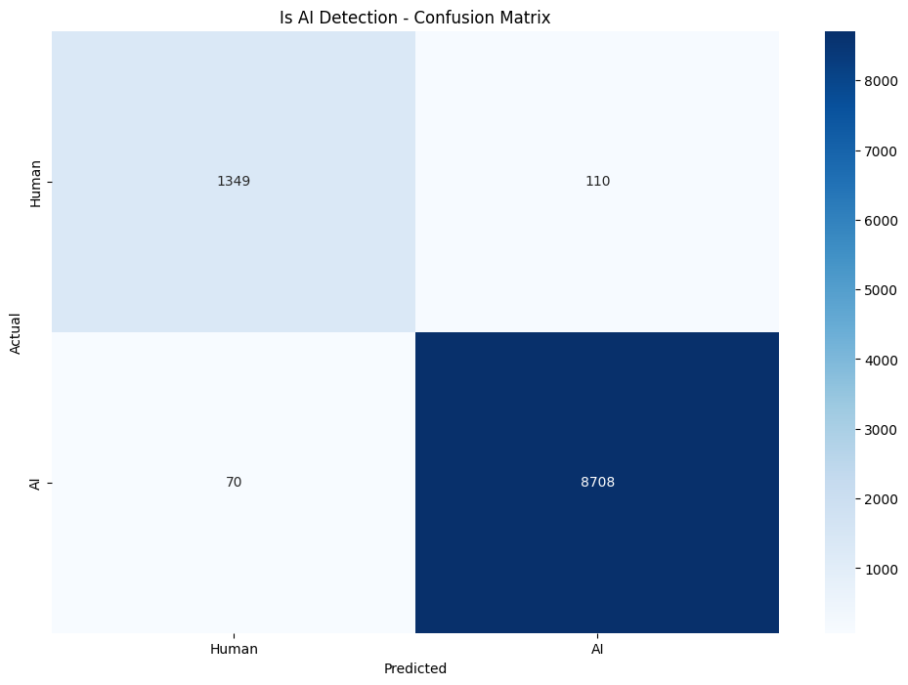
figure 1 : Confusion Matrix for Ai-vs-Human using for XGboost
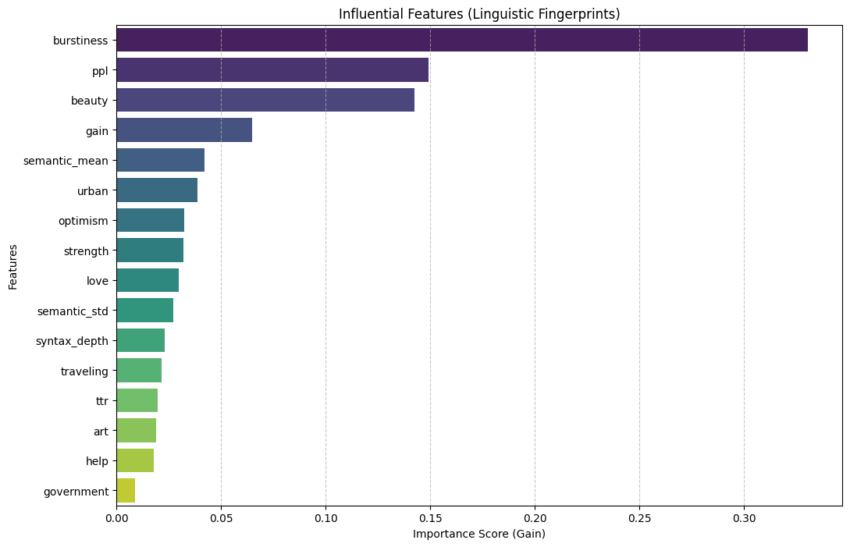
Figure 2: Feature Importance for AI-vs-Human using XGBoost.
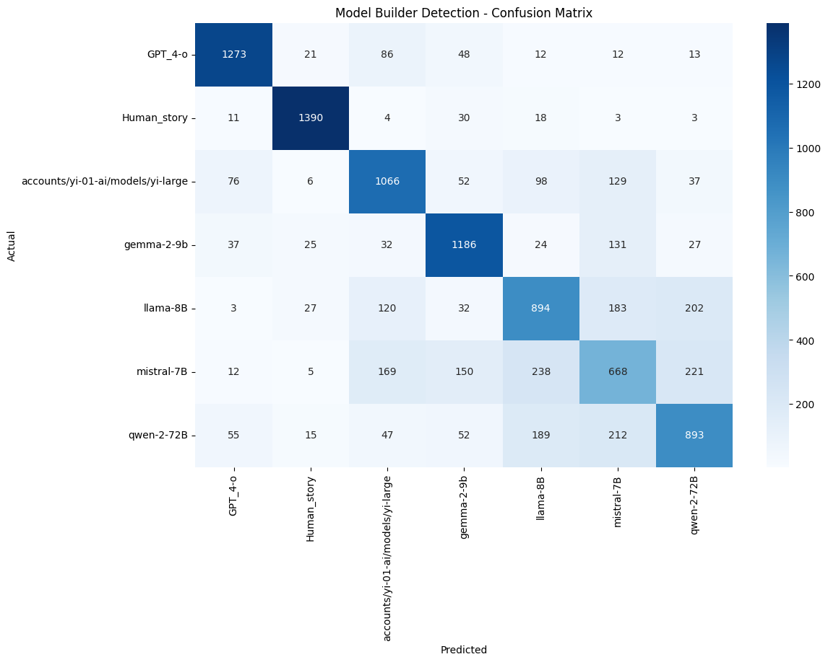figure 3 : Confusion Matrix for model prediction using for XGboost

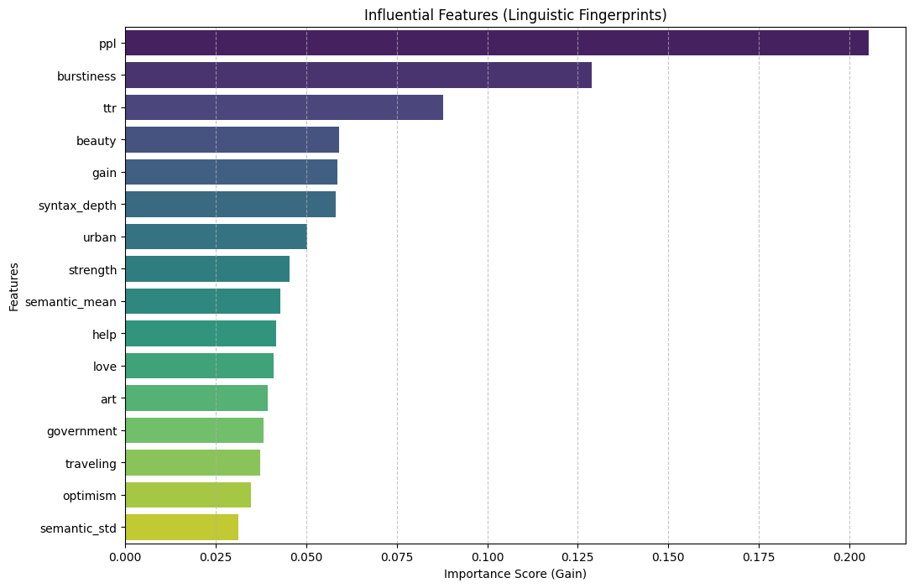
Figure 4: Feature Importance for model prediction detection using XGBoost.

Overall, XGBoost outperformed the other models in both binary classification (human vs. AI-generated text) and multi-class classification (identifying the specific AI model). This performance can be attributed to XGBoost's well-known capability to handle structured data and effectively capture complex patterns. Furthermore, since most models performed well, we believe that with a comprehensive set of features, AI-generated news can be detected with high accuracy and efficiency—which explains why the baseline model performed poorly in the first place.

Project Outcomes
- Pipeline Development: Successfully developed a scalable pipeline that utilizes diverse linguistic and statistical features for the detection of AI-generated text.
- Model Training & Evaluation: Trained and evaluated multiple machine learning models to determine their effectiveness in text classification.
- Performance Comparison: Conducted a comparative analysis of various algorithms, identifying XGBoost as the superior model.
- Binary Classification Success: Achieved high performance in distinguishing between human-written and AI-generated text.
- Multi-class Classification Success: Successfully implemented model attribution to identify the specific AI model used to generate the text.

Reference
[1] NewsGuard, "Rise of the Newsbots: AI-Generated News Websites Proliferating Online," 2024. [Online]. Available: https://www.newsguardtech.com/special-reports/ai-tracking-center/ (Updated 2025).
[2] K. Hao, "Junk websites filled with AI-generated text are pulling in money from programmatic ads," MIT Technology Review, June 26, 2023. [Online]. Available: https://www.technologyreview.com/2023/06/26/1075504/junk-websites-filled-with-ai-generated-text-are-pulling-in-money-from-programmatic-ads/
[3] P. Patwa et al., "Overview of constraint 2021 shared tasks: Detecting English COVID-19 fake news and Hindi hostile posts," in Combating Online Hostile Posts in Regional Languages during Emergency Situations, Cham: Springer, 2021, pp. 1–12.
[4] N. Karimi and J. Gambrell, "Hundreds die of poisoning in Iran as fake news suggests methanol cure for virus," The Times of Israel, March 27, 2020.
[5] M. Morales et al., "Covid-19 tests gone rogue: Privacy, efficacy, mismanagement and misunderstandings," 2021, arXiv:2101.01693. [Online]. Available: https://arxiv.org/abs/2101.01693
[6] Sathyabama Institute, "SKDU at De-Factify 4.0: Natural Language Features for AI-Generated Text-Detection," in Proceedings of the 4th Workshop on Multimodal Fact-Checking and Hate Speech Detection (De-Factify 4.0), AAAI, 2025.
[7] S. Ji et al., "A Survey of AI-generated Text Forensic Systems: Detection, Attribution, and Characterization," arXiv preprint arXiv:2310.08182, 2023.
[8] G. Singh, "A Comprehensive Dataset for Human vs. AI Generated News Content," Hugging Face, 2024. [Online]. Available: https://huggingface.co/datasets/gsingh1-py
[9] G. Singh, "gsingh1-py Training Dataset," Hugging Face Repository, 2024. [Online]. Available: https://huggingface.co/datasets/gsingh1-py/train?library=datasets

Team Role
Basel Ahmed Sardah:
- Data Collection and Preprocessing
- Feature Extraction Implementation
- Model Training and Evaluation
- Result Analysis and Report Writing

Appendix
Source code : https://github.com/BaselCS/ai_text_detection
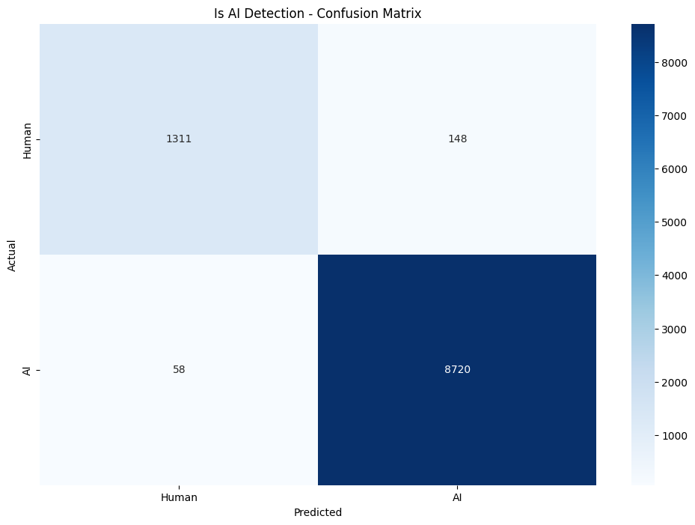

figure 5 : Confusion Matrix for Ai-vs-Human using for RF
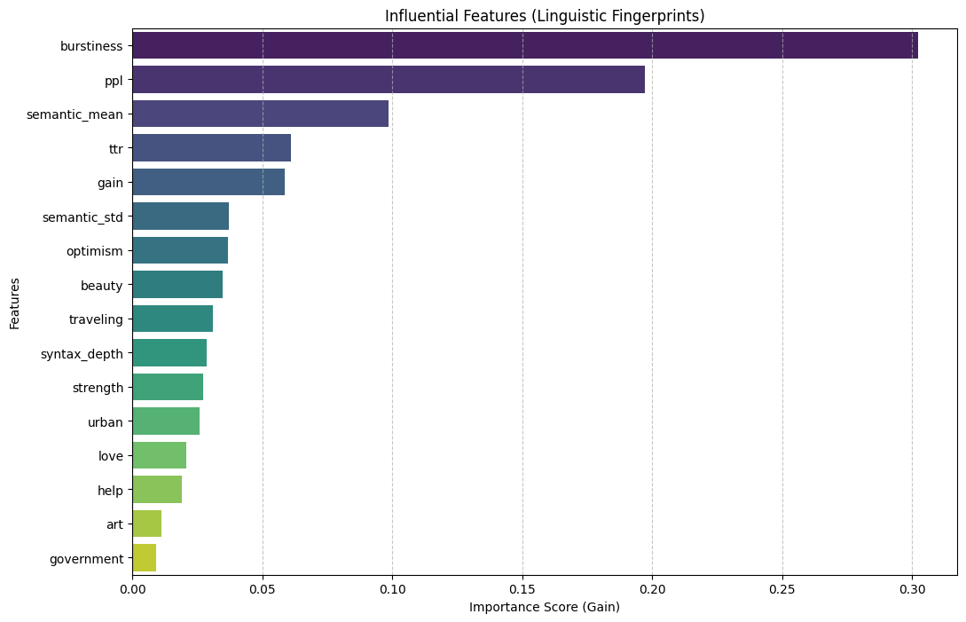
Figure 6: Feature Importance for AI-vs-Human using RF

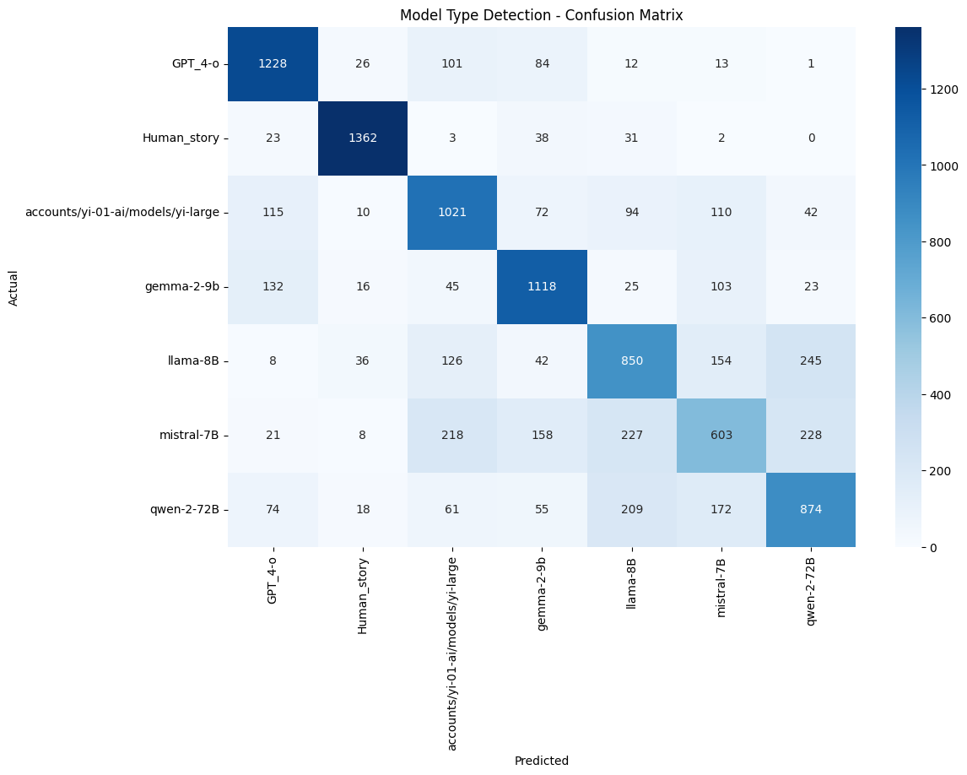.
figure 7 : Confusion Matrix for model prediction using for RF
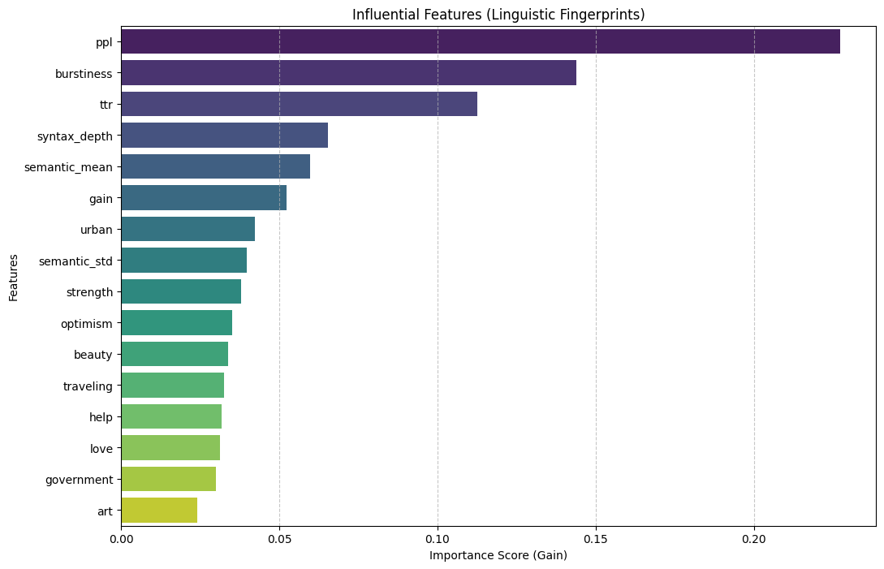
Figure 6: Feature Importance for model prediction using for RF

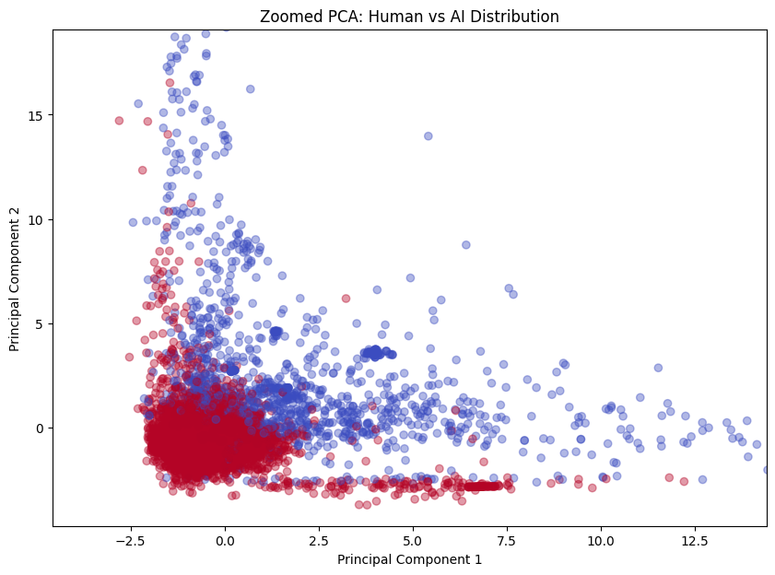
Figure 8: SSV plotting for Ai-vs-Human using

Proof of Adherence to Ethics and Integrity

Throughout this project, strict ethical guidelines were followed to ensure the integrity and credibility of the work. All research sources, including academic papers, datasets, and online resources, have been properly cited. The dataset employed in this study was obtained from a reputable source (Hugging Face) and used in accordance with its licensing terms. Significant care was taken to avoid plagiarism by ensuring that all text, ideas, and data presented are original or appropriately attributed. Furthermore, an AI-based assistant was utilized for code debugging, structural organization, and linguistic refinement to ensure clarity and a professional academic tone. However, all conceptual frameworks, experimental designs, and final data interpretations remain the original work of the author."

